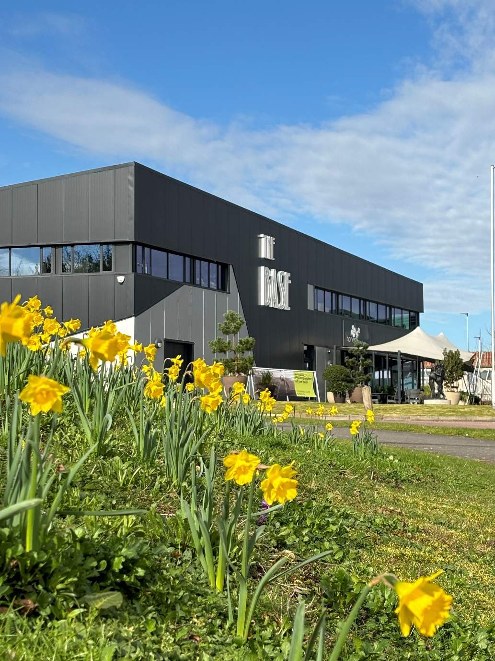
Joan Miró:
Painting and Poetry
Visual Story
Hello, we are very much looking forward to welcoming you to The Base. These notes are for you to read before your visit to Joan Miró: Painting and Poetry at The Base. They tell you more about our building and what happens inside, so that you will know what to expect.



Welcome to The Base
This is the front entrance to The Base. The first door will open automatically when you approach it, then turn left and go through the second automatic door on the left-hand side.

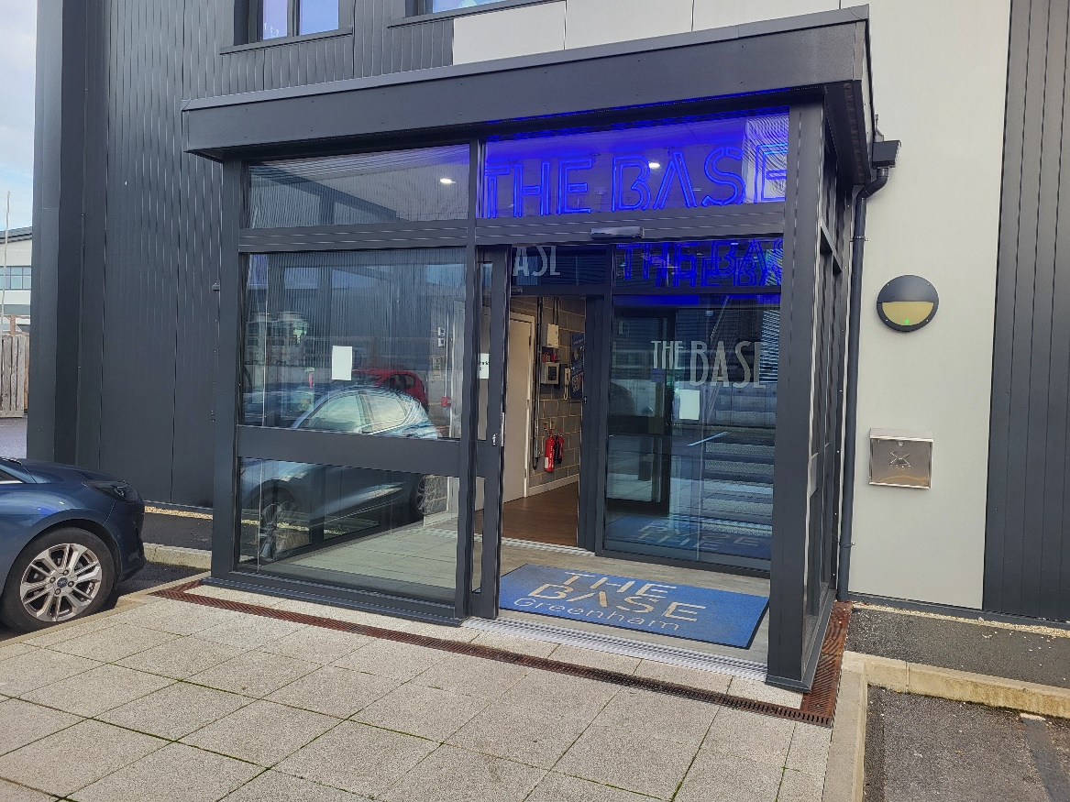

When you walk through the door, follow the corridor around the corner. This will take you to Joan Miró: Painting and Poetry in the Gallery.
There are also signs to help you find your way around.
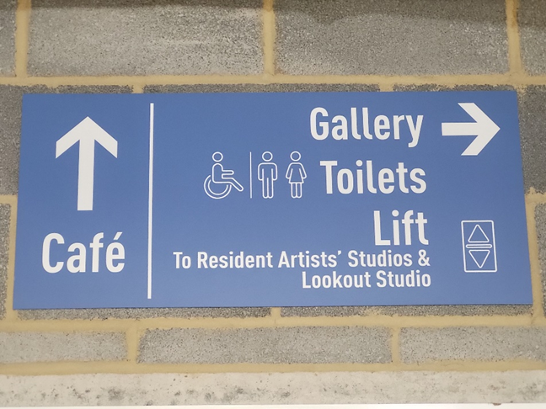
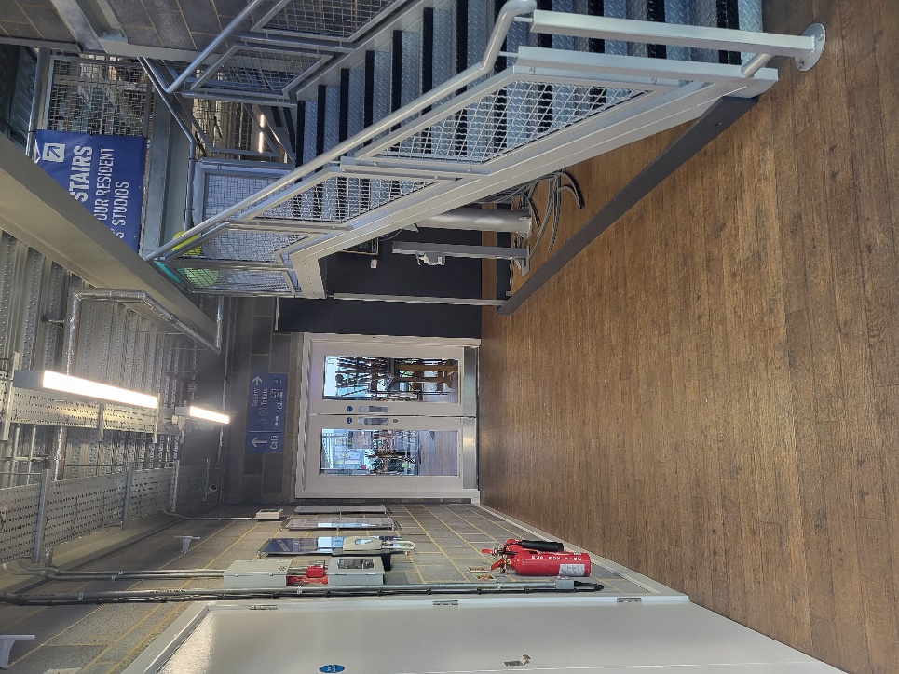
TOILETS
We have turned off all hand dryers for the Relaxed Day and provided paper hand towels instead.

There are toilets just by the entrance to the Gallery. | If you’re upstairs, you can find them halfway down the corridor.
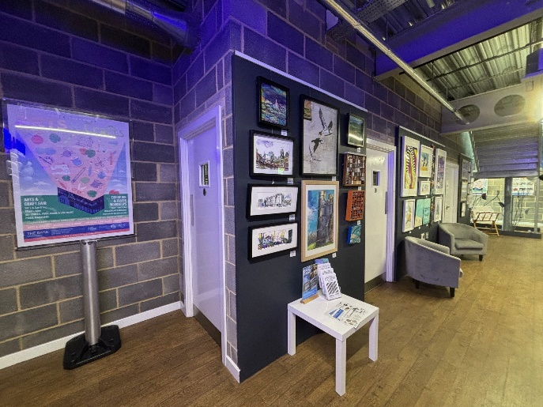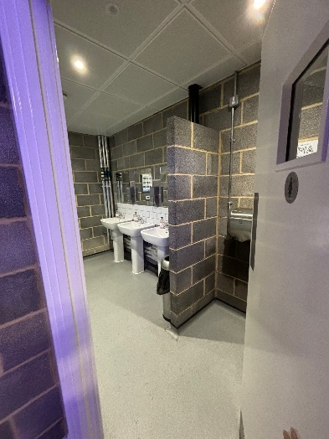 | 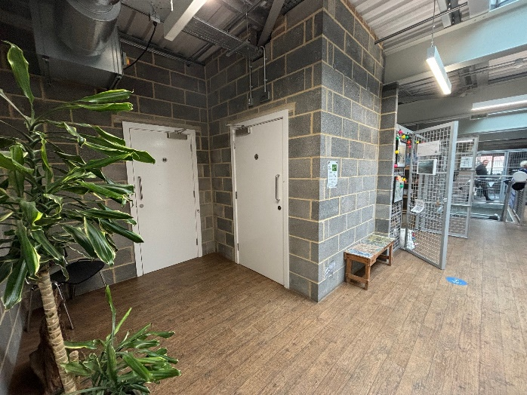

A gallery assistant will be at the desk to greet you and tell you about the exhibition.

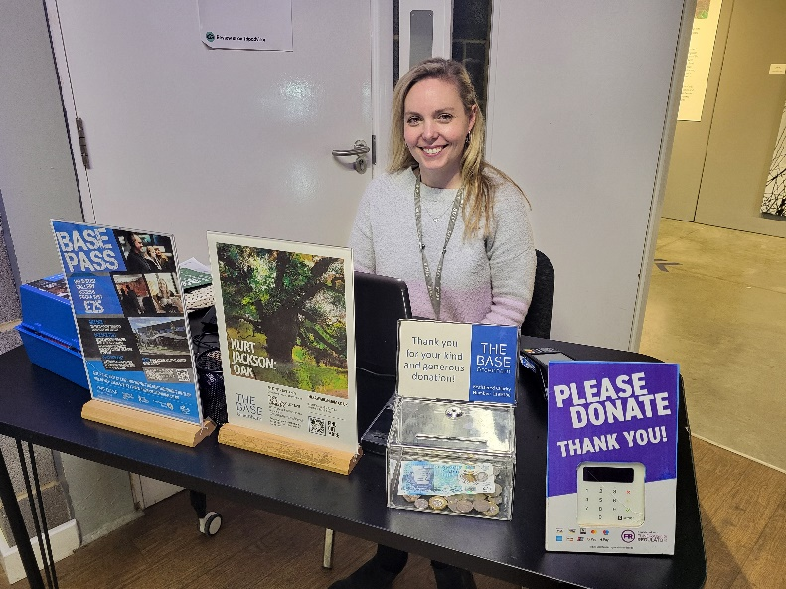

If you have any questions during your visit, speak to a member of our team (who all wear grey lanyards) - we are happy to help in any way we can. Or you can write a message down and show them if you would prefer.

As you walk into the Gallery, this is what you will see first...
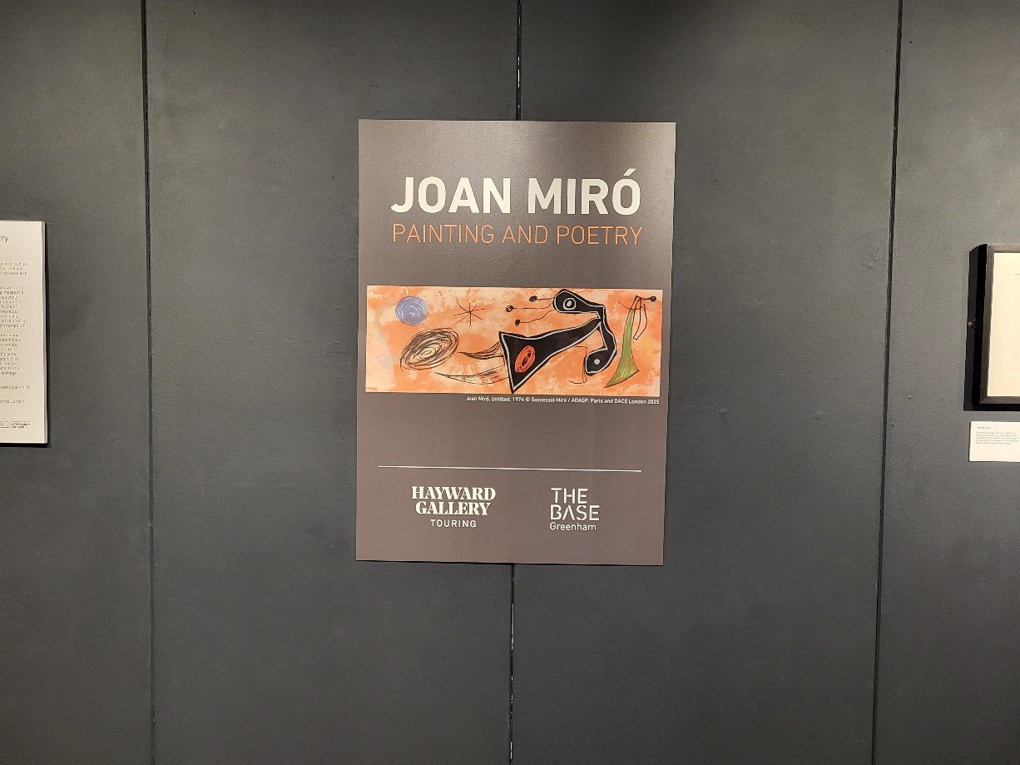

There might be other people visiting the exhibition at the same time as you. Although it is quite quiet in the Gallery, you will hear other people talking.

You can explore the exhibition in any order that you like and spend as much time as you like looking at the pieces of art.

In the middle of the exhibition there is a creative area. There are chairs for you to sit on, books for you to look at, a fuzzy felt activity and colouring for you to do if you choose.

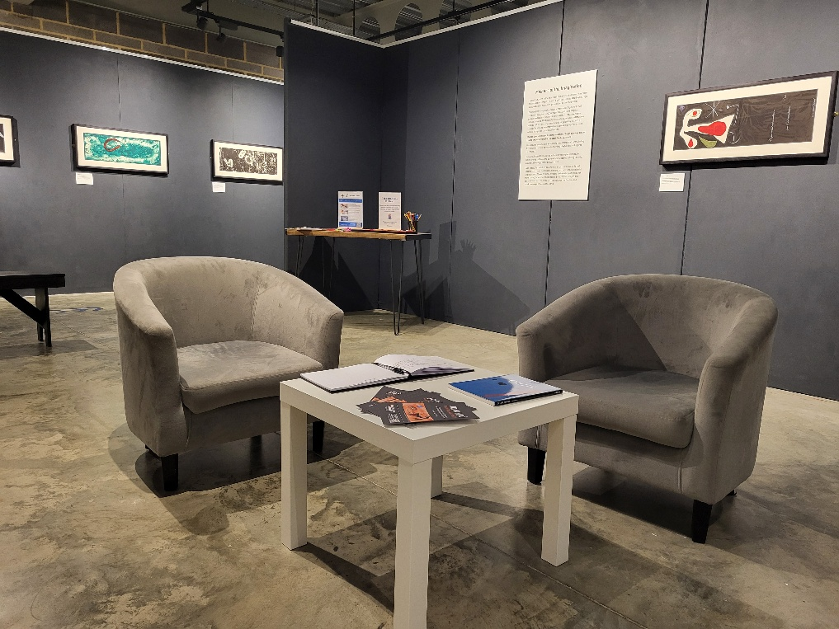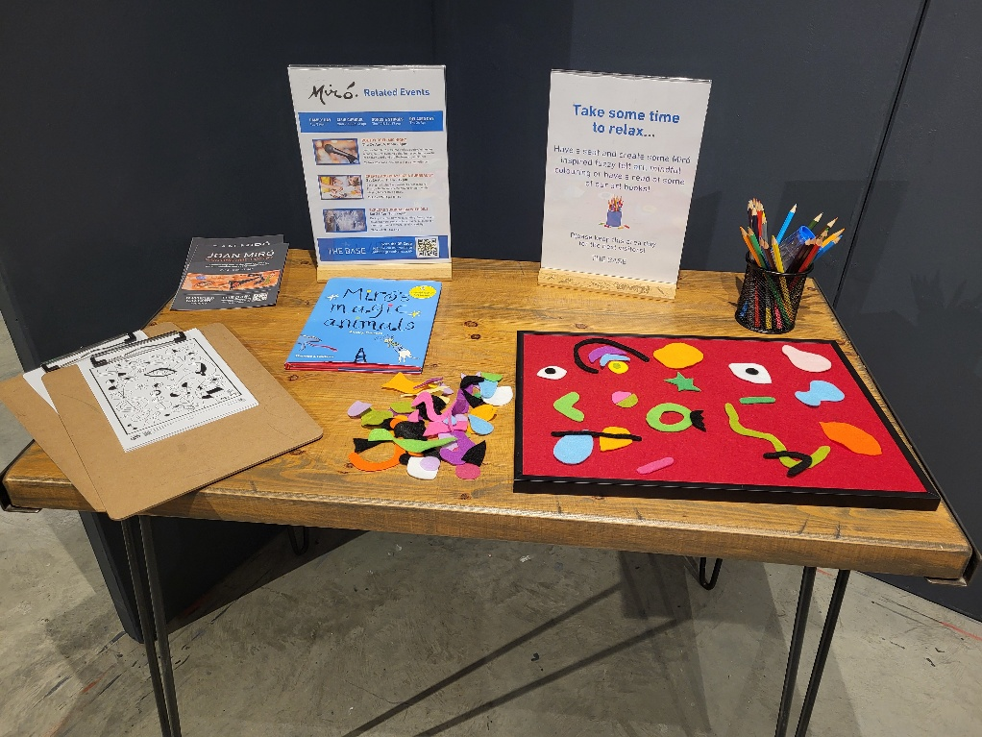

If you are sensitive to noise, please ask the gallery assistant if you can borrow some ear defenders.

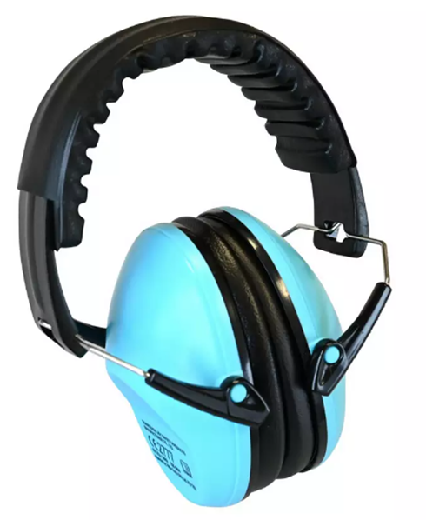

You can also go upstairs to look at our resident artists’ studios.
There is also a lift that you can use instead of the stairs. (It is quite slow though!)

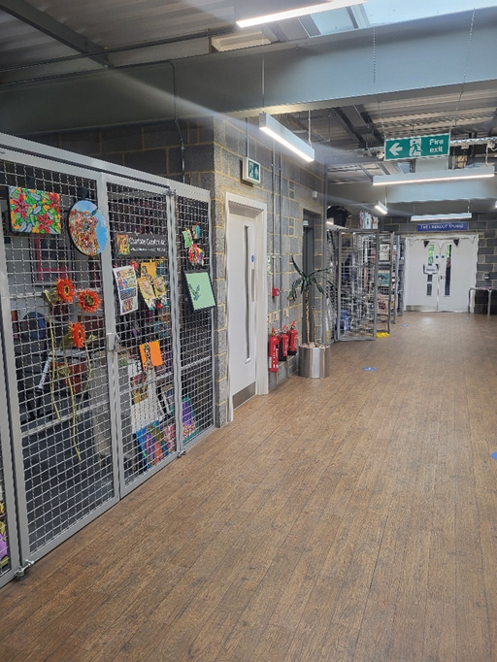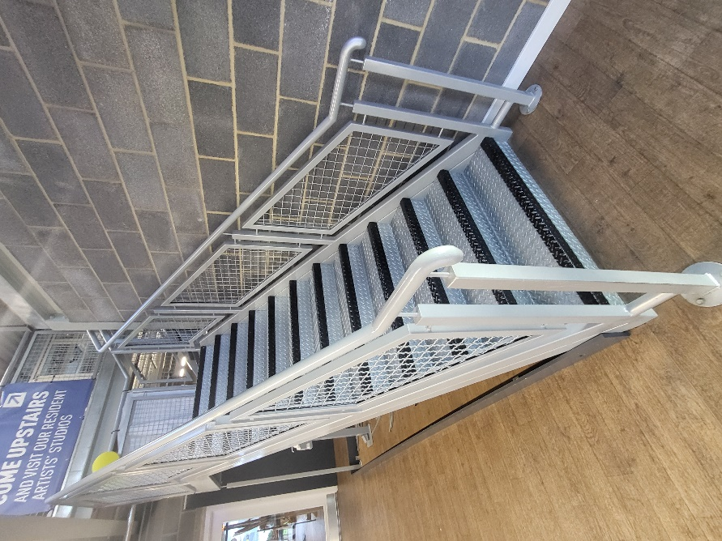
There is a café at The Base. Strong smells, like coffee or hot food, may spread out of the café into the rest of the building.

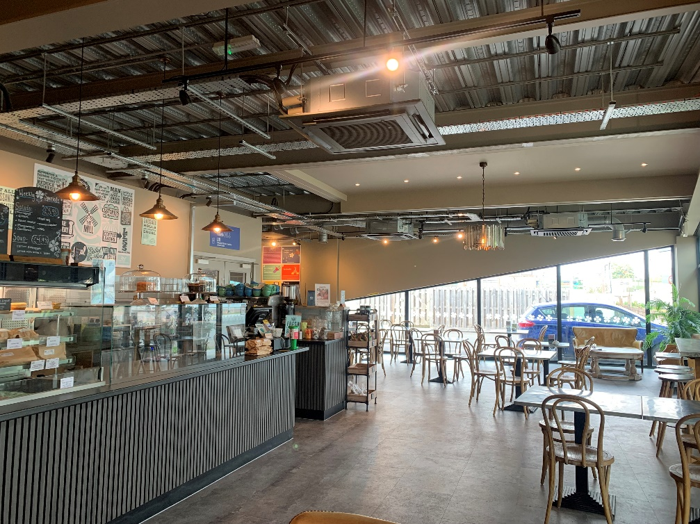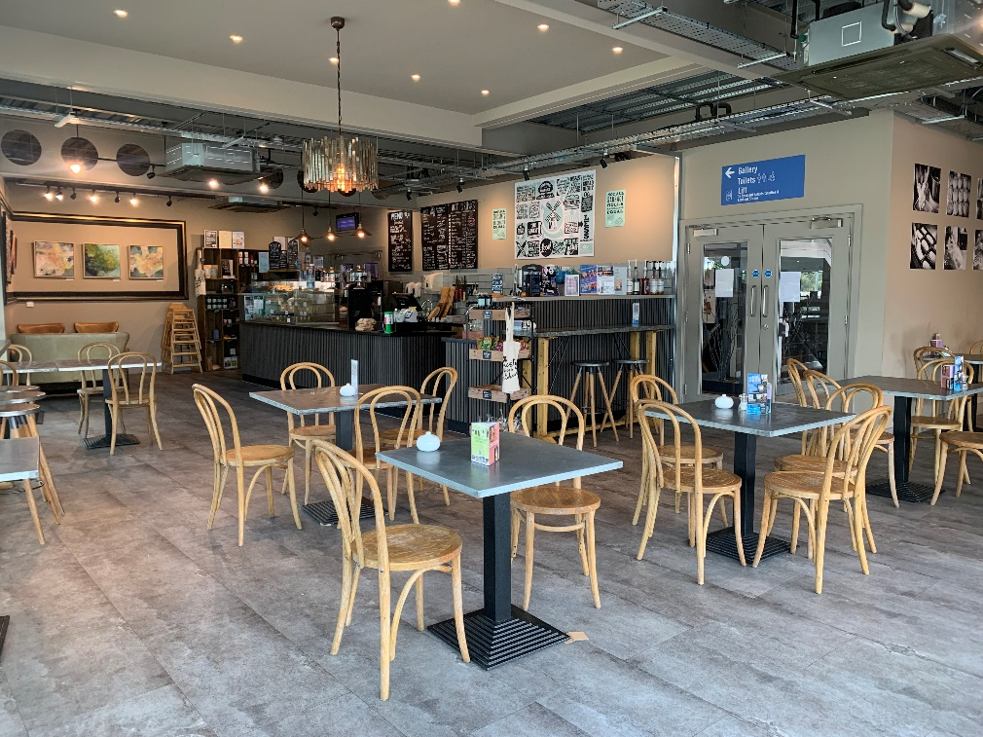

Inside the café can be busy and noisy with loud coffee machines and lots of customers talking.
We hope you enjoy your visit to The Base.

If there is anything we can do to make your visit more comfortable, please speak to a member of our team or email admin@thebasegreenham.co.uk

